Lab: Data Visualization (Sumo Logic)
Introduction
In this lab, I explored the concept of Data Visualization in Sumo Logic and learned how dashboards can be used as a powerful forensic and monitoring tool. Dashboards allow analysts to view critical log and metric data together in a single, unified interface. By visualizing trends, patterns, and anomalies, dashboards make it easier to quickly interpret system activity, identify security issues, and support faster decision-making.
This lab also introduced the dashboard template capabilities that simplify data scoping and make chart creation more intuitive. Through hands-on tasks, I learned how to create dashboards, add different types of panels, and modify panel content to suit specific monitoring requirements.

What I Did in This Lab
In this lab, I had created a new dashboard in Sumo Logic and added different panels to it. I had customized each panel by editing the search queries and selecting the appropriate visualization. I had also adjusted the dashboard layout and updated the panel settings. By the end of the lab, I had built a complete dashboard that clearly displayed important log and metric data.
First, I had clicked on New and then selected Log Search. After that, I had chosen the source category and selected Cisco Meraki logs to begin building my panel.
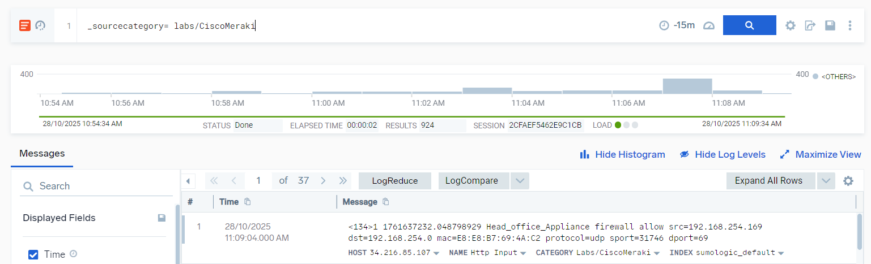
When I had clicked on New, a dropdown menu had appeared, and from the bottom of that list, I had selected Dashboard.
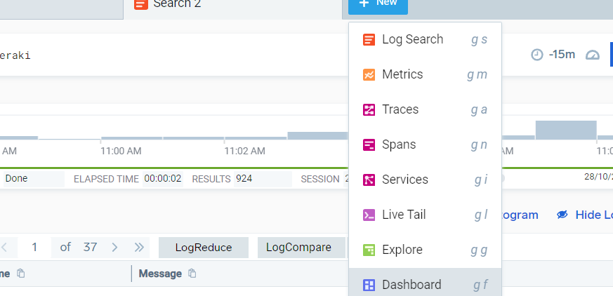

When the new window opened, I entered the following query:
_sourceCategory=Labs/CiscoMeraki
| parse "firewall * src=* dst=* mac=* protocol=* sport=* dport=*"
as action, src_ip, dst_ip, mac, protocol, sport, dport
| timeslice 5m
| count by _timeslice, action
| transpose row _timeslice column action
I used this query to show the traffic trend for “allow” versus “deny” actions.
It helped me see how many requests were allowed or denied within each selected time frame.
- First, the query filtered only the Cisco Meraki logs.
- Then it parsed the log line to extract important fields such as action, source IP, destination IP, ports, and protocol.
- Next, I grouped the data into 5-minute time slices.
- After that, I counted how many allow and deny events occurred in each time slice.
- Finally, I transposed the results so I could clearly compare “allow” vs “deny” traffic on a time-series graph in the dashboard.
After creating the dashboard, I clicked Add to Dashboard in the upper-right corner to save the panel. Later, when I selected the same dashboard and made changes, the button changed to Update Dashboard, allowing me to save the new edits.
All the dashboards I created appeared in the Personal Library, where I could easily access and manage them.
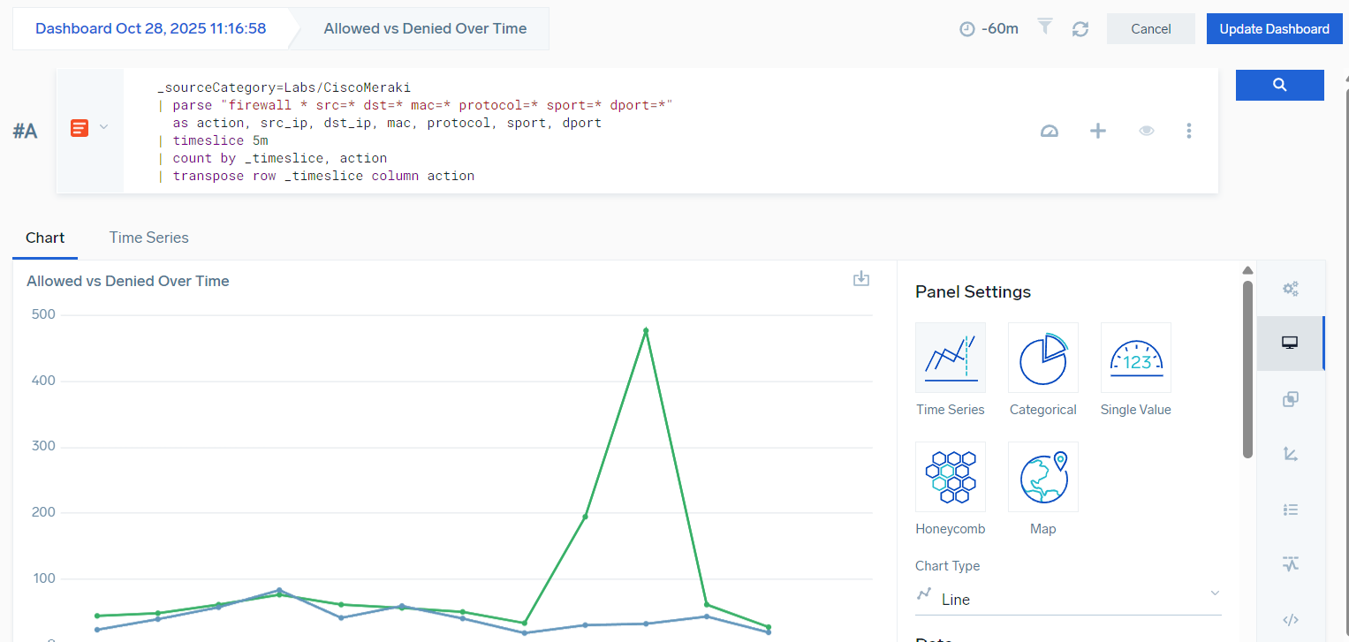
Next, I used the same method by clicking New → Dashboard, and in the new panel I entered the following query to create a visualization for destination ports:
_sourceCategory=Labs/CiscoMeraki
| parse "firewall * src=* dst=* mac=* protocol=* sport=* dport=*"
as action, src_ip, dst_ip, mac, protocol, sport, dport
| count by dport
| sort by _count desc
| limit 10
This panel showed me the top destination ports, helping me identify which ports were most frequently targeted or used. It was useful for spotting potential scanning activity or abused services.
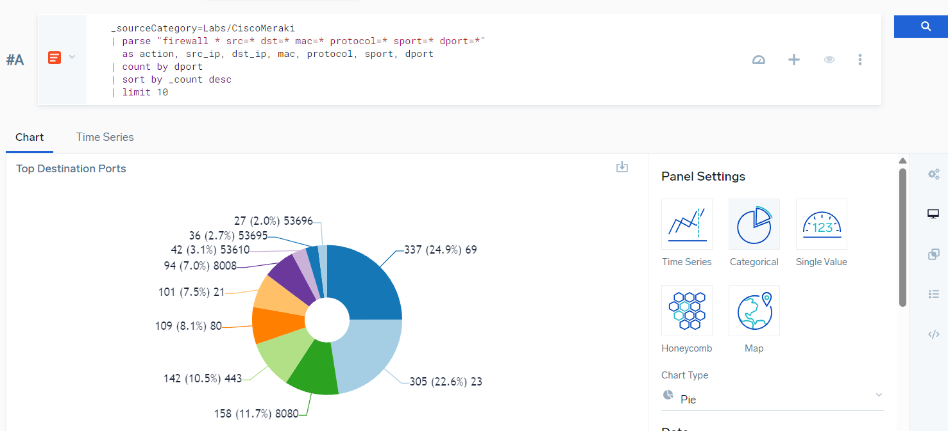
Next, I created a panel for Top Denied Destination IPs using the Categorical panel type. I entered the following query:
_sourceCategory=Labs/CiscoMeraki "firewall deny"
| parse "firewall * src=* dst=* mac=* protocol=* sport=* dport=*"
as action, src_ip, dst_ip, mac, protocol, sport, dport
| count by dst_ip
| sort by _count desc
| limit 10
This panel highlighted the destination IPs that had the most denied traffic in last 60 minutes, helping me identify potentially malicious hosts or unauthorized access attempts.
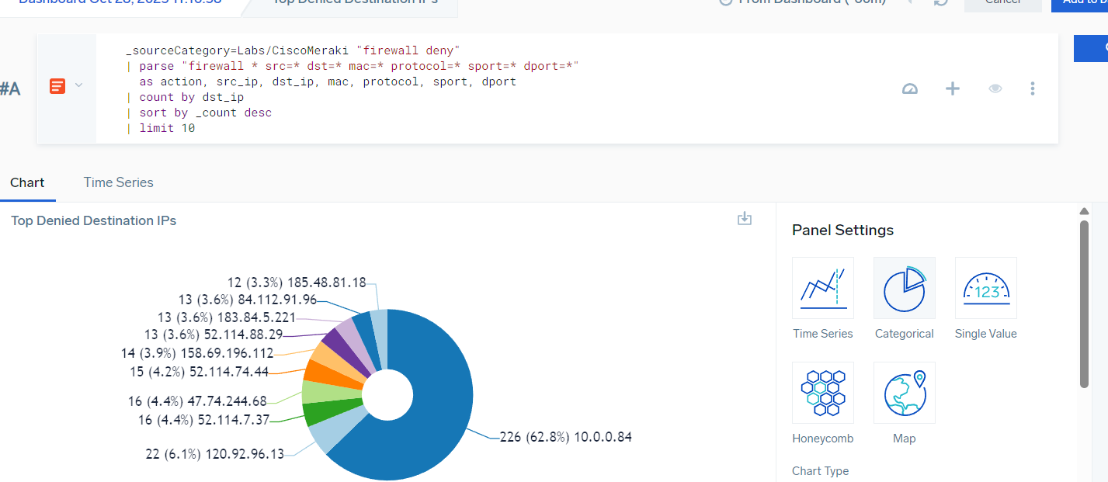
Next, I created a panel for Top Internal Talkers (Most Active Source IPs) using the Categorical panel type. I entered the following query:
_sourceCategory=Labs/CiscoMeraki
| parse "firewall * src=* dst=* mac=* protocol=* sport=* dport=*"
as action, src_ip, dst_ip, mac, protocol, sport, dport
| count by src_ip
| sort by _count desc
| limit 10
I set the time frame to the last 60 minutes. This panel allowed me to identify internal hosts with the heaviest network activity, which could indicate compromised systems or unusually high usage.
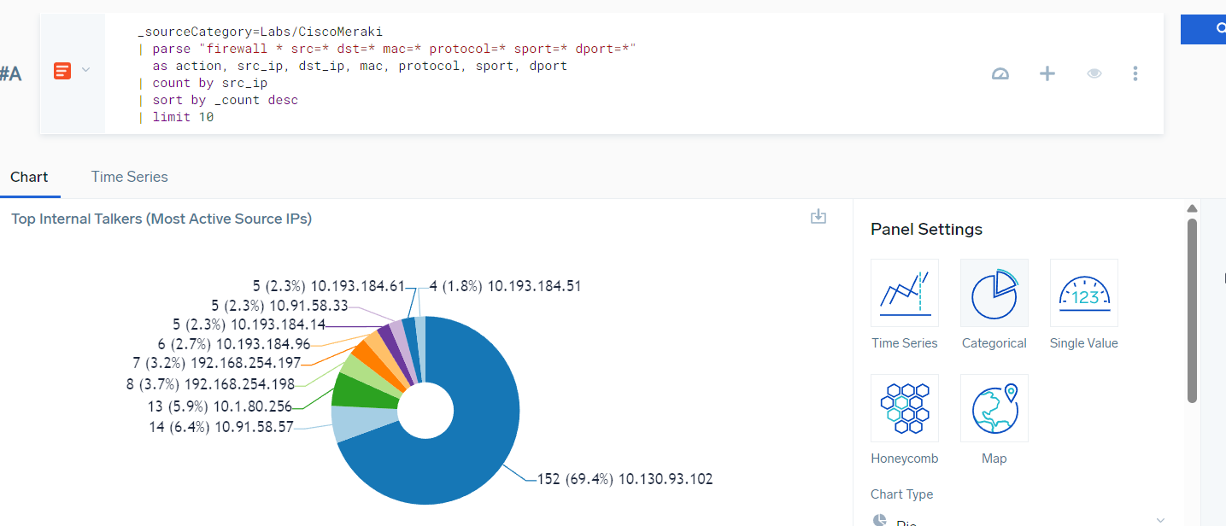
Next, I created a Categorical (Pie Chart) panel to analyze traffic by protocol. I entered the following query:
_sourceCategory=Labs/CiscoMeraki
| parse "firewall * src=* dst=* mac=* protocol=* sport=* dport=*"
as action, src_ip, dst_ip, mac, protocol, sport, dport
| count by protocol
| sort by _count desc
This panel showed the breakdown of traffic by protocol (TCP, UDP, etc.), which was useful for detecting anomalies, such as a sudden spike in UDP traffic.
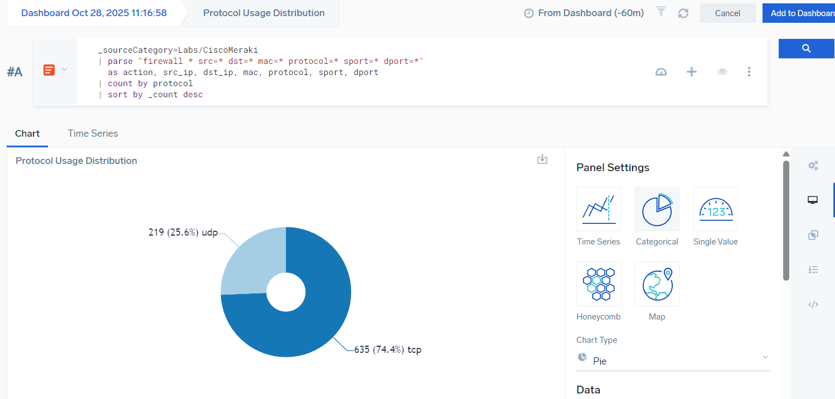

As I progressed, I kept adding each panel to the dashboard, so that all the visualizations were available in a single view. This included panels for traffic trends (allow vs deny), top destination ports, top denied destination IPs, top internal talkers, and protocol breakdown.
The final dashboard provided a comprehensive view of network activity, allowing me to monitor traffic patterns, identify potential threats, and analyze anomalies all in one place.
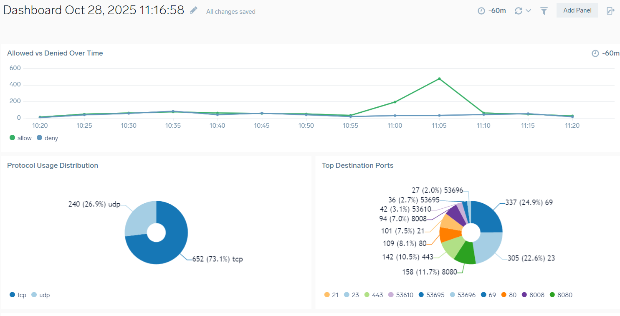
I had also switched the dashboard to dark mode, which made the visualizations easier to read and provided a clearer view of all the panels.
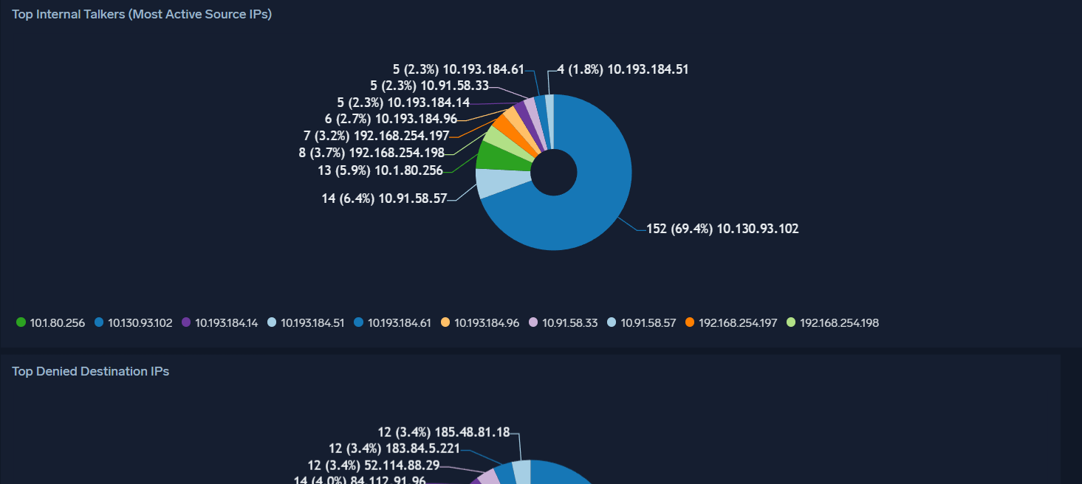

When I clicked the three dots in the upper-right corner, I could switch back to white mode.
I could also schedule the dashboard reports to be sent to my email.
Additionally, I could save the dashboard to my personal library for easy access later.
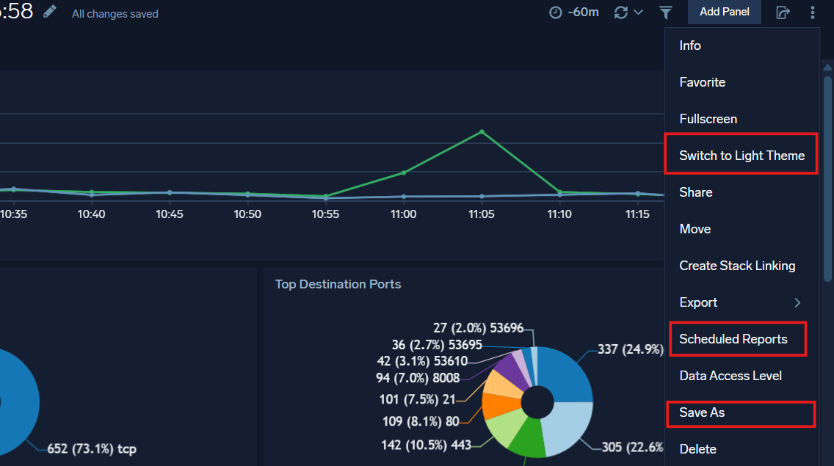

Conclusion
In this lab, I had learned how to create and customize dashboards in Sumo Logic to visualize network and firewall log data. I had built multiple panels showing traffic trends, top ports, denied destinations, active internal hosts, and protocol breakdowns. This lab was important because it taught me how to quickly analyze network activity, identify anomalies, and monitor security events in a visual and intuitive way. By the end, I had gained hands-on experience in using dashboards as a powerful tool for network monitoring and threat detection.

